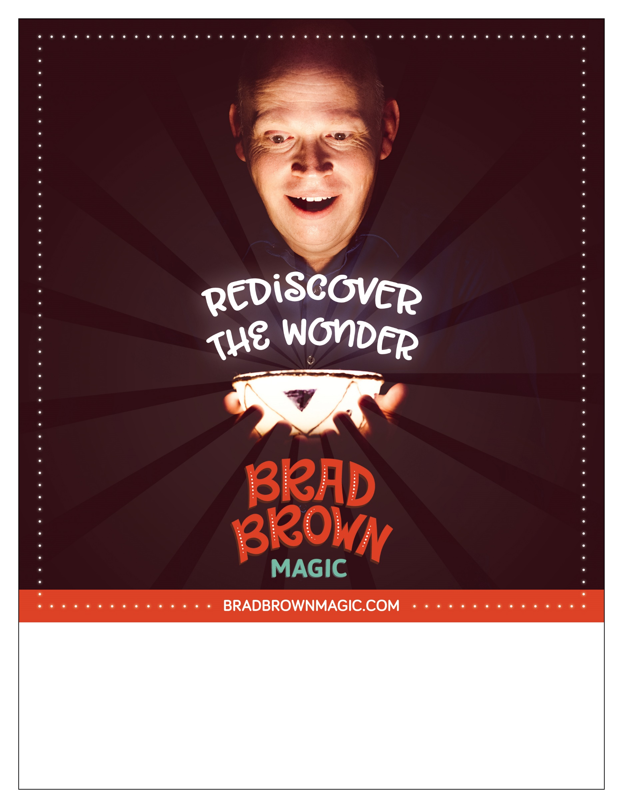

**MAIN HEADING**

**SUB HEADING**

Event details go here. Event details go here. Event details go here. Event details go here. Event details go here. Event details go here. Event details go here. Event details go here. Event details go here.